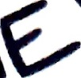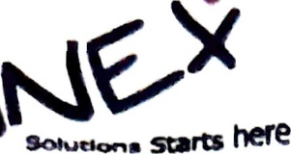

**CERTIFICATE**

This is to certify that **G.HARSHA VARDHAN** bearing the **H.T.NO:1117109** from, **SREE VIDYANIKETHAN INSTITUTE OF MANAGEMENT**, student of **MCA**, have successfully completed the project titled **“USERS INFORMATION FOR INTERACTIVE OPERATIONS IN STOCK TRADING USING KEY ATTRIBUTES”** as part of the course curriculum in our organization.

He has done a project using **PYTHON T**echnology during the period **JAN-2020 TO APR-2020**. Under the guidance and supervision of **Mr. K. SUJAN KUMAR**, from **Annex Solutions, Hyderabad.**

He has completed the assigned project well within the time frame. He is sincere, hardworking and his conduct during period is commendable.

We wish all the best in his future endeavour.

